**EDGE Data Science Project work**

**Research title:** Evaluating the Impact of Mobile Healthcare Education on Self-Management of Type 2 Diabetes in Rural Bangladesh: An Observational Intervention Study

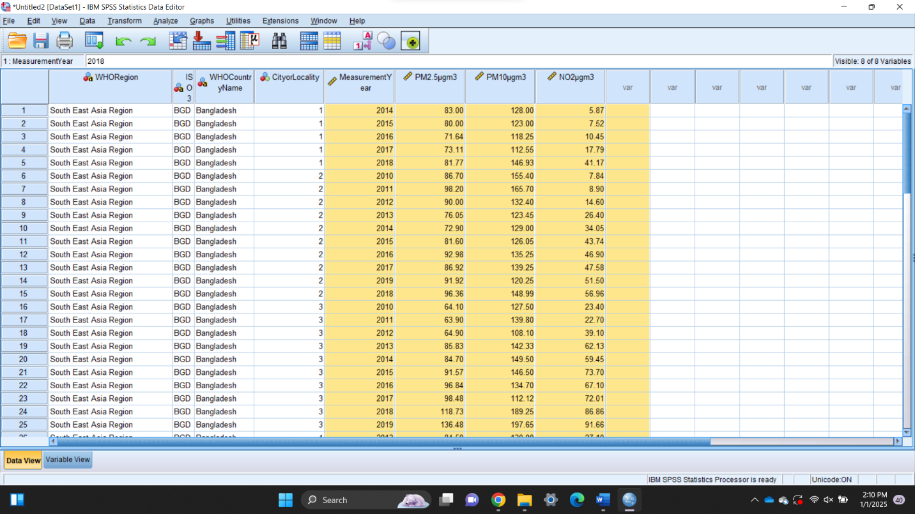**Overview:** This study evaluates the impact of mobile healthcare education platforms on enhancing self-management behaviors among individuals with Type 2 diabetes in rural Bangladesh. Using an observational intervention design, 100 participants from rural clinics were divided into control and intervention groups. Baseline data on clinical indicators, self-management practices, and diabetes awareness were collected, followed by a one-month intervention with post-assessment. Results indicate significant improvements in the intervention group, including better medication adherence, dietary habits, physical activity, and reduced HbA1c and fasting glucose levels. The findings highlight the potential of digital health solutions in improving chronic disease management in resource-constrained settings.

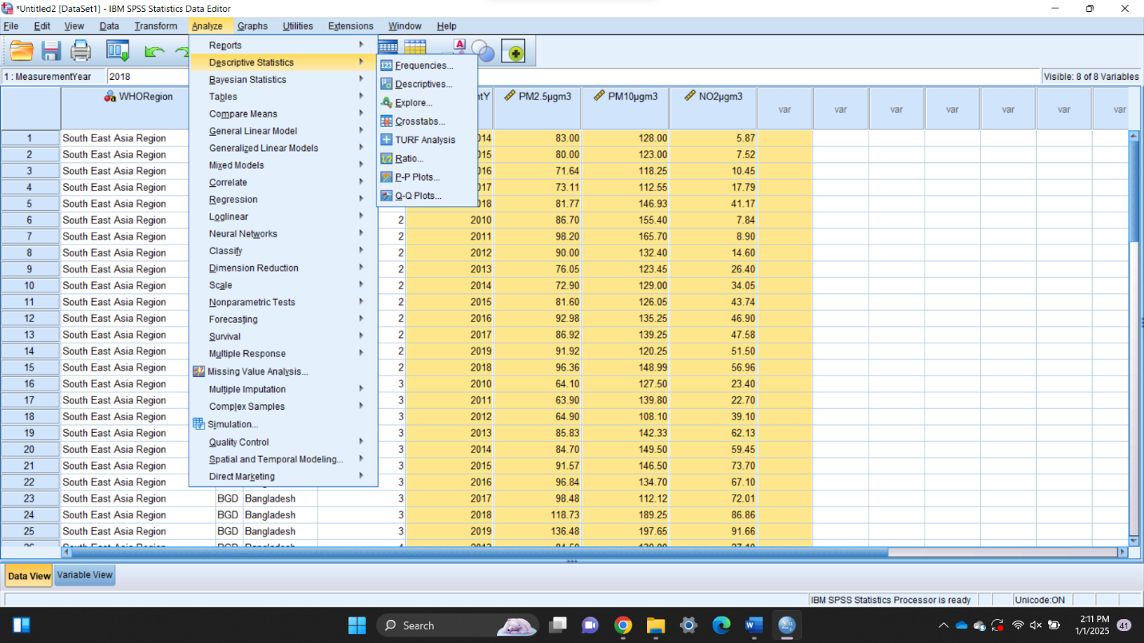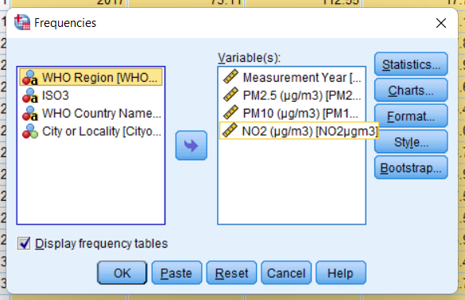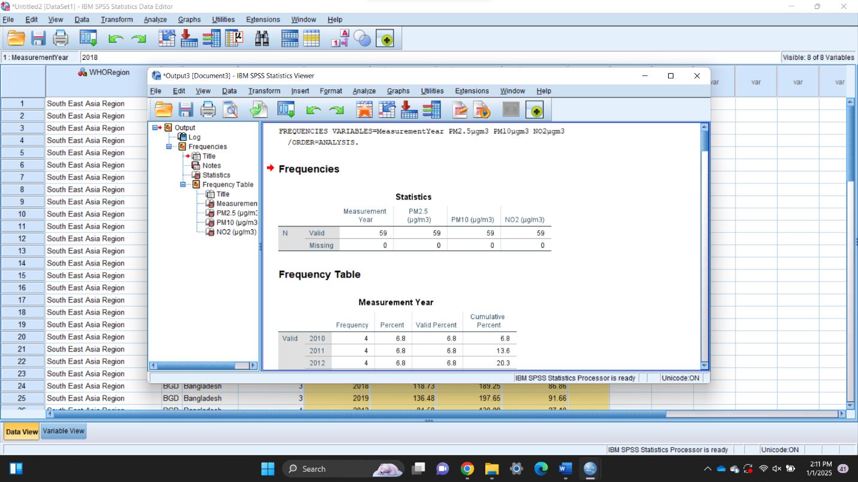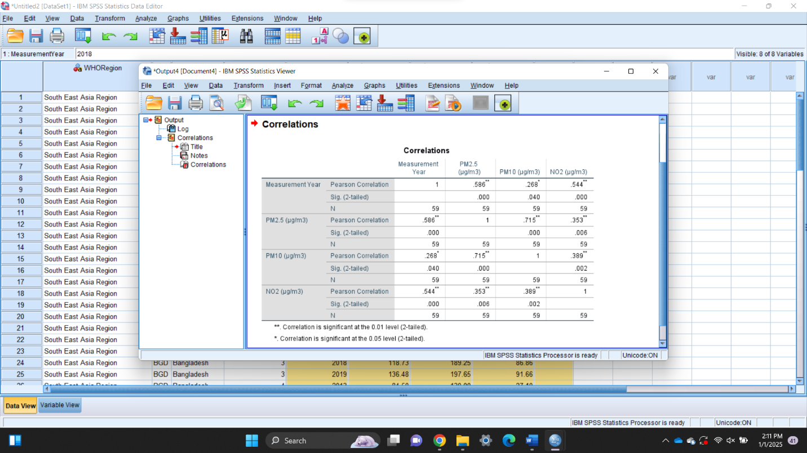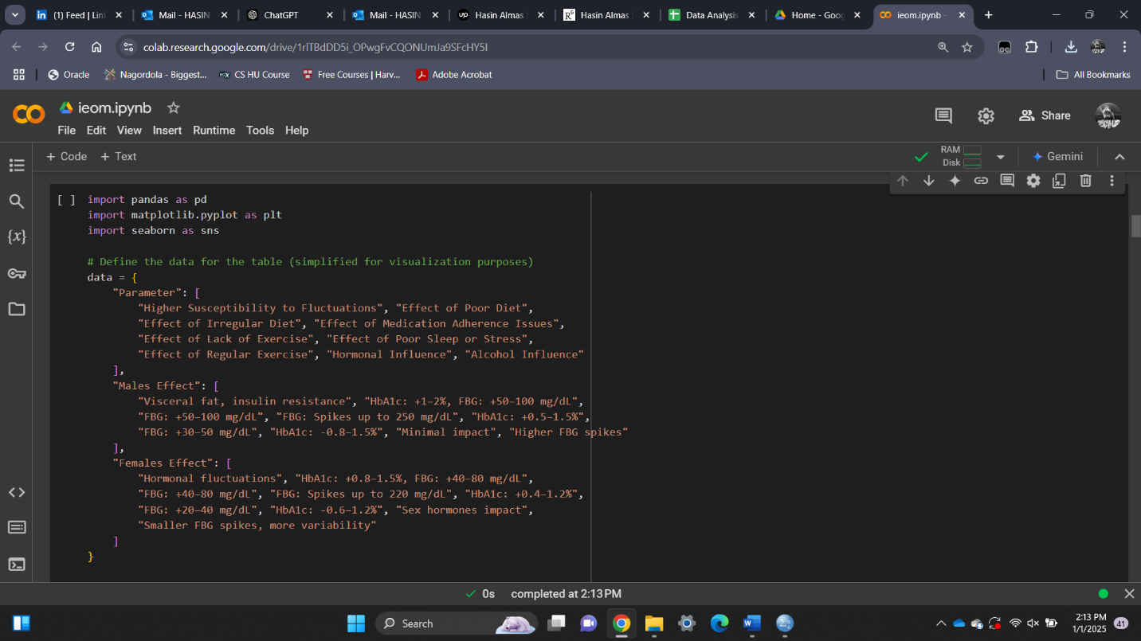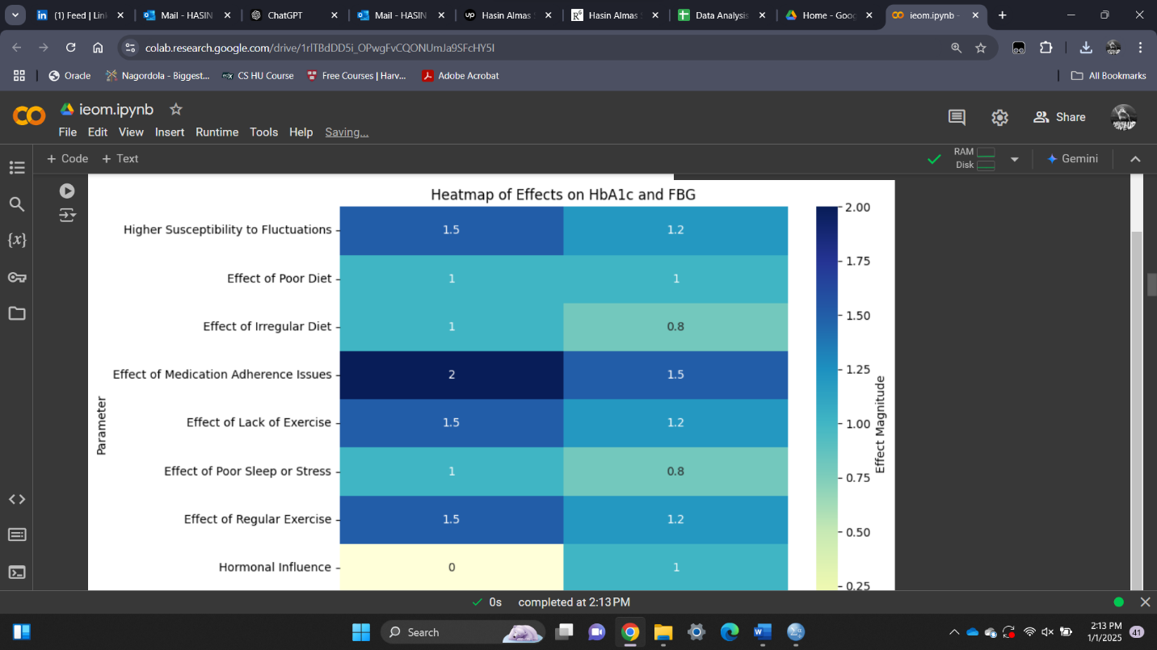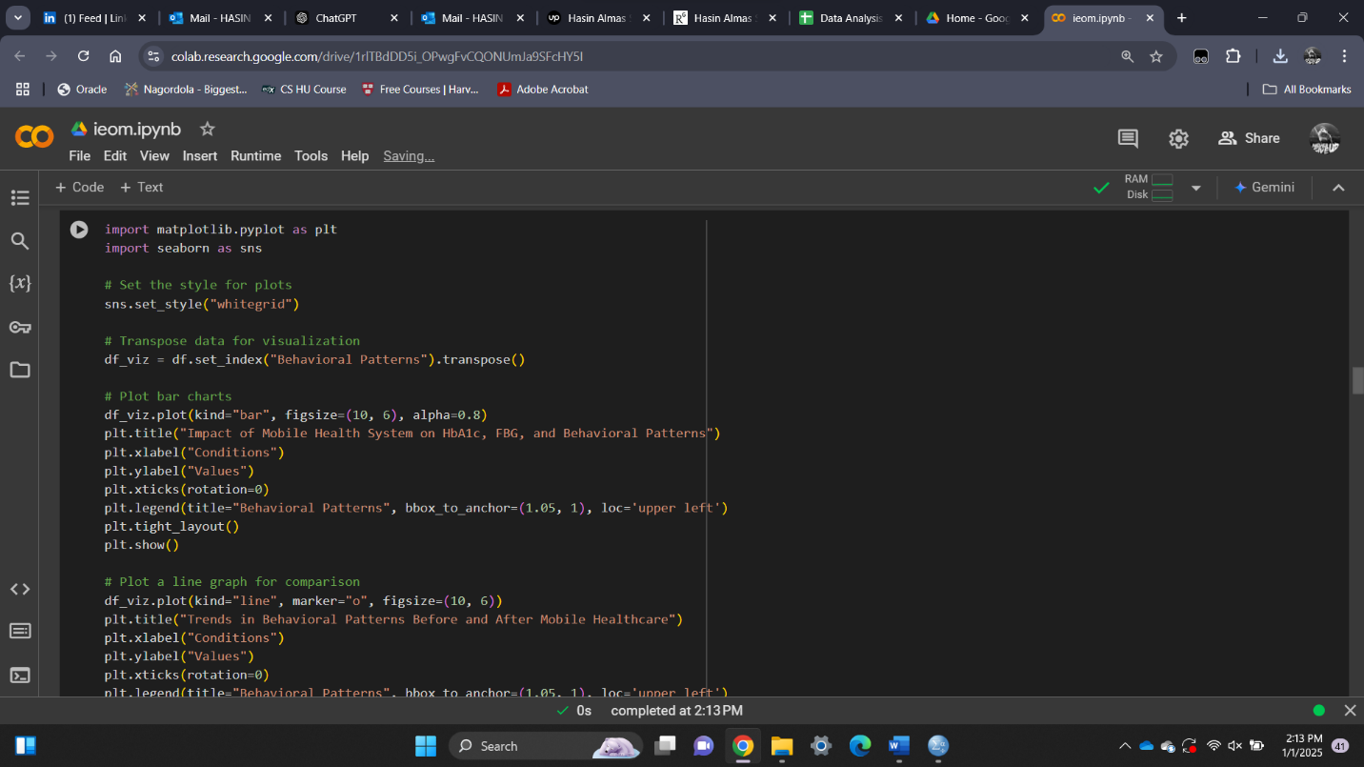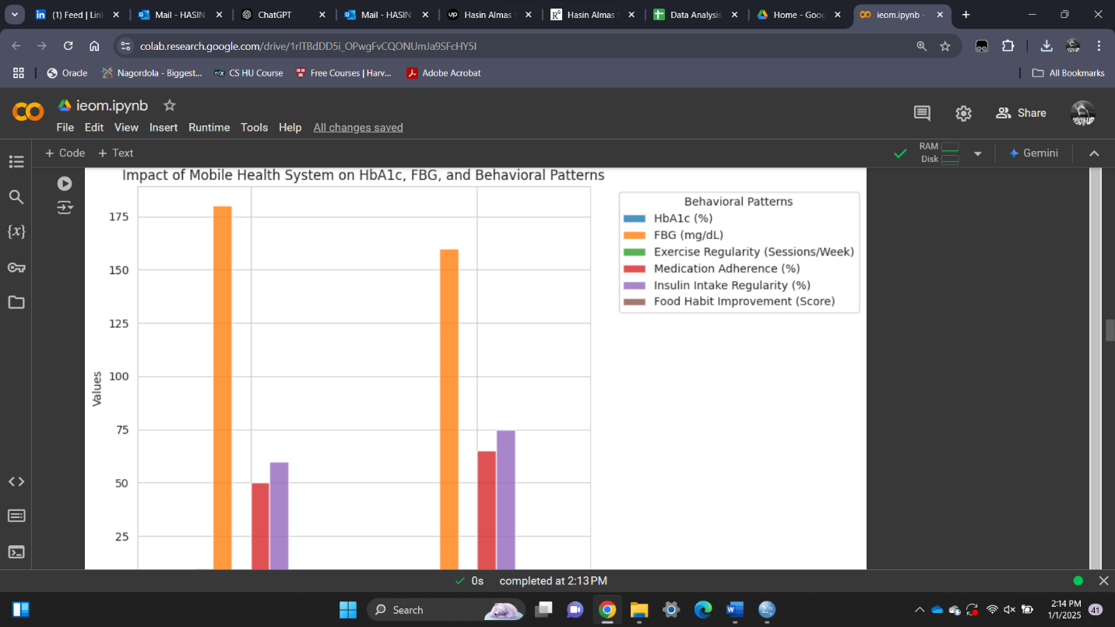

**Outcome summary:**

